Unit Group Project 4 – Code Explanation

Antz Claveus, Ethan Carter, Oscar Garcia, and Thomas Lilchin
Department of Engineering and Technology, Miami Dade College
COP 2800: Java Programming
Dr. Martins Idahosa
April 18, 2026

Welcome to our Group Project 5! We would like to begin this code explanation by demonstrating our UML diagram. This diagram was done with the help of the website called diagrams.net. 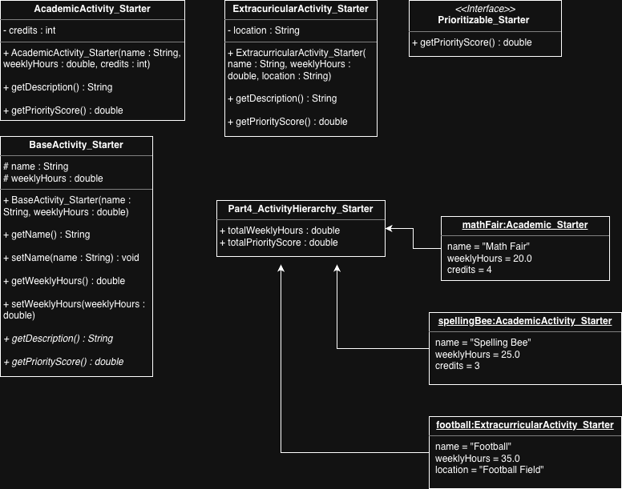
Our program focused on representing the two main activities that a student does: academic and extracurricular activities. To speak on its output, our program outputs a summary of each activity done, including name, weekly hours, and credits. Finally, it includes another summary that includes total weekly hours and total priority score.

Though our base class and subclasses were defined for us out the get-go, we will attempt to explain why these particular class and subclasses were used. For our base class – BaseActivity_Starter – we chose this class to be, quite what its name implies, the base of our activities. We defined this base class with a name and weeklyHours variables as it is the two fields that both AcademicActivity_Starter and ExtracurricularActivity_Starter share. Next, the subclasses were chosen as they encompass the majority of activities that a student does in their life. Typically, a student will either have academic or extracurricular activities – and anything in between is generally covered by these two types of activities.
Regarding what fields and methods truly belong to our base class, we would argue that all of them do. Specifically, the fields name and weeklyHours and their respective getters and setters all truly belong to the base class as all activities have a name and weekly hours that will be dedicated to it.
3. When it comes down to the @Overriding methods: 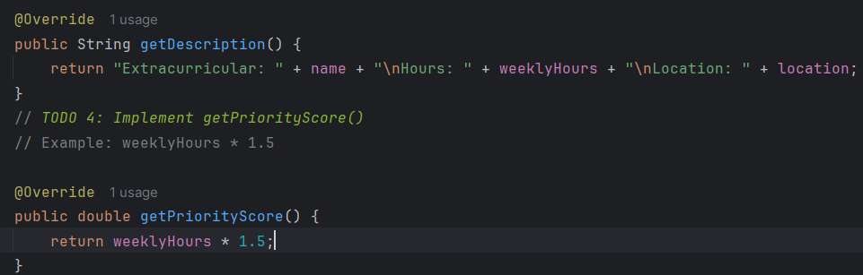 this allows for better flexibility in the code since it overrides the current method from the parent class, so in any case, if a method name or parameter has any typo, it will give a compile error rather than the program running with unnoticed errors. Additionally, it allows different implementations of the method to be made in each class.
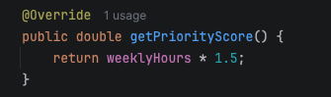
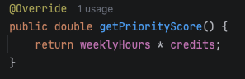
Now, on the topic of interfaces, our only use of interfaces was Prioritizable_Starter. The sole role of this interface was to setup a method named getPriorityScore() that will fetch the priorityScore. This method was later implemented in AcademicActivity_Starter and ExtracurricularActivity_Starter. (The first screenshot shows the overridden method for AcademicActivity_Starter, and the second screenshot shows the overridden method for ExtracurricularActivity_Starter).

In regard to the use of polymorphism to simplify our array processing code, we did not use polymorphism to loop through the array – we simply used a for-each, or enhanced-for loop.
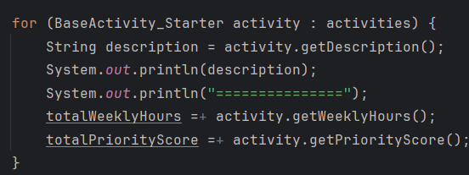
In terms of arrays, the only limitation to using them is that the objects all must be of BaseActivity_Starter type. In defense of the program, though, there is no need for any other type other than BaseActivity_Starter. Additionally, if any objects needs to be added to the array, it can be retroactively added since the array is not a fixed size (uses brackets to hold objects).
From BaseActivity_Starter, we inherited the AcademicActivity_Starter as well as the ExtracurricularActivity_Starter. This was completely logical and did not overcomplicate the code as BaseActivity_Starter served as a generic base for what would become of AcademicActivity_Starter and ExtracurricularActivity_Starter. For example, we set up name and weeklyHours along with its respective constructor getters and setters. This gives us a solid and logical base to build off of. So in short, no, inhertiance did not make our code design more complex than necessary.
In terms of adding a new activity type to our hierarchy, it would be pretty simple. This would take us making a new class that extends from BaseActivity_Starter and implements Prioritizable_Starter. Then, within this class, we would set up any needed variables for this new activity, then, set up a constructor with the necessary fields, including any declared in BaseActivity_Starter and any new fields set up in this new class.

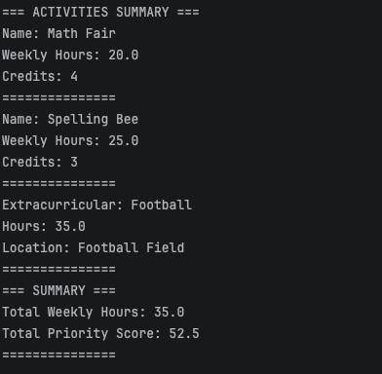
To check that the overridden methods were actually being called at runtime, - specifically, we are talking about getDescription and getPriorityScore - all that we did was check our output! Our output looks like this:
. We can see that, for the first two activities/objects, the overridden method of AcademicActivity_Starter was used - and for the last activity/object, the overridden method of ExtracurricularActivity_Starter was used, as evidenced by the differences in output ("Name" vs "Extracurricular", "Weekly Hours" vs "Hours", "Credits" vs "Location").
Our activity hierarchy, we have two parts: Academic and Extracurricular. In our opinion, this hierarchy perfectly reflects real student activities because a typical student does either academic activities or extracurricular activities. For example, a student might go to high school and go to karate practice. Or a student might go to university and go to tennis practice afterwards.

